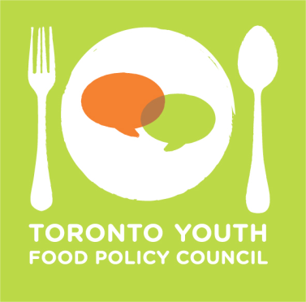
DESCRIPTION FOR COUNCIL MEMBERSHIP

Operations Lead

The Operations Lead is responsible for the following:

- Maintaining and responding to the general TYFPC email account (info@tyfpc.ca); organizing the logistics & administration of each monthly meeting; improving Council processes and making strategic recommendations to the TYPFC Executive and broader council.
- Researching, updating and maintaining the Events Calendar.
- Co-coordinate one community meeting with other council members.

A person in this role should:

- Have strong organizational and time-management capabilities.
- Have strong communication skills.
- Be self-motivated to meet deadlines.
- Be comfortable with web platforms (e.g. WordPress, administering Google email accounts).

Other requirements:

- All applicants selected for council positions must attend a mandatory 2 day strategic planning retreat in September.
- All council members are required to attend monthly council and committee meetings the first Monday of the month.

How to apply:

- Deadline: send a completed application and resume to applications@tyfpc.ca by July 31, 2017, 9:00am.
- Submission Email Subject Line: ‘Communications Application – Your Name’.
- Successful applicants will be contacted for interviews in August.

The TYFPC welcomes applications from all interested food passionate youth, regardless of experience or background, between the ages of 16 and 30. We encourage applications from diverse communities, including Indigenous, racialised, disabled, queer, and trans* youth. We welcome all experiences (i.e. lived and academic), and encourage applicants to note this in their application.

