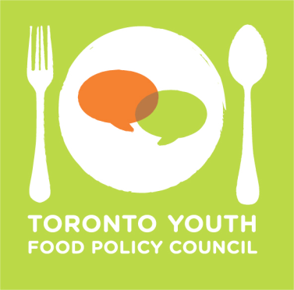
DESCRIPTION FOR COUNCIL MEMBERSHIP

Advocacy Committee Co-Lead

The Advocacy Committee Co-Lead is responsible for the following:

- Research: engage the TYFPC network in local food policy issues.
- Advocacy: offer a youth perspective on food issues while representing the TYFPC at meetings, events, public deputations, and other speaking opportunities.
- Outreach: develop and lead discussions on food in collaboration with other advocacy organizations.
- Co-coordinate one community meeting with other council members.

A person in this role should:

- Demonstrate interest in municipal food policy issues.
- Be comfortable making presentations and facilitating group discussions.
- Demonstrate an ability to take initiative and responsibility for projects.
- Be comfortable in both a research and advocacy capacity.
- Be interested in generating content for TYFPC's website and social media.

Other requirements:

- All applicants selected for council positions must attend a mandatory 2-day strategic planning retreat in September.
- All council members are required to attend monthly council and committee meetings the first Monday of each month.

How to apply:

- Deadline: send a completed application and resume to applications@tyfpc.ca by July 31, 2017, 9:00am.
- Submission email subject line: Advocacy Committee Application – Your Name.
- Successful applicants will be contacted for interviews in August.

The TYFPC welcomes applications from all interested food passionate youth, regardless of experience or background, between the ages of 16 and 30. We encourage applications from diverse communities, including Indigenous, racialised, disabled, queer, and trans* youth. We welcome both lived and academic experience, and encourage applicants to note this in their application.

